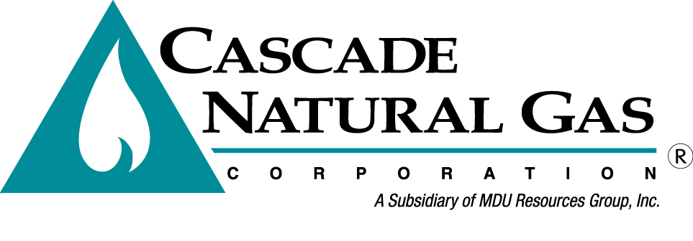
OPUC Tag Meeting 1

Date & Time: 8/15/2020, 09:00 AM – 11:15 AM
Location: Springhill Suites in Bend, OR – Deschutes Room
In attendance: Mark Sellers-Vaughn, Brian Robertson, Devin McGreal, Linda Offerdahl, Bruce Folsom, Chris Robbins, Eric Wood, William Gherke
Called in: Alyn Spector, Ashton Davis, Monica Cowlishaw, Mike Parvinen, Kevin Connell, Tammy Nygard, Chad Stokes (Cable Huston), Laura Johnson (NWP), Jim Cordaro (Ruby), Mark Iverson (Ruby), Mike Paruszkiewicz (NWN), Anna Kim (OPUC)
Minutes by: Brian Robertson

Mark Sellers-Vaughn kicked off the meeting by thanking everyone that showed up. Brian went over fire safety of the building, introductions and the agenda.
- Mark gave a quick background of the history of Cascade Natural Gas.
- Brian Robertson hit on the main points of the purpose of the IRP:
  - It is a regulatory rule.
  - Transparent road map of the company’s 20-year plan.
  - Promotes internal coordination.
  - Serves as a tool for other filings such as a rate case.
- Bruce Folsom discussed the IRP Process:
  - TAG meetings are very important to receive feedback.
  - Receiving feedback in a timely manner will help the current IRP.
  - Milestones are important. Beginning parts of the IRP feed the end of the IRP, if milestones are missed then it pushes back other milestones.
- Brian went over the Best Practice Discussion:
  - Pointed out that Cascade created a Stakeholder Engagement Document to be used for the IRP process.
  - Noted again that receiving feedback on a timely manner will help serve the current IRP process.
- Brian introduced and showed all the members who are a part of the internal IRP team.
- Ashton Davis discussed the Regional Market Outlook:
  - Noted the Enbridge event and the future timeline of repairing Enbridge.
  - Noted the update on the hedge level moved to 60%. William Gherke asked what the previous hedge percentage was. Ashton responded with 40%.
  - Ashton also noted other information regarding other items such as the US economy, natural gas projections, Jordan Cove, and upstream GTN open season.
- Cascade then discussed Key Items that will be heavily discussed and involved in the IRP:
  - Ashton discussed the forecast model. He also expressed the difficulty of getting housing start information in our rural cities/towns.
  - William questioned the usage of wind in the use per customer model and stated that he hasn’t seen it elsewhere. Ashton responded that Cascade has found it to be significant in our models. He also noted that Northwest Natural Gas uses it.
  - Devin explained the hedging process that is currently going on in Washington.
  - Devin discussed the upcoming plans for the avoided cost. Specifically, adding distribution system cost, hourly modifier, and risk premium. Anna asked if that was too much in one IRP. Devin responded that most of this work has been done within UM 1893 so it shouldn’t be that much additional work. William asked about the Environmental Adder. Devin responded that the 10% environmental adder is from NWPCC power plan.
  - Alyn Spector touched on the energy efficiency slides and that Cascade is working closely with ETO. He also noted that Cascade will be analyzing various carbon reduction scenarios.
  - Chris Robbins discussed renewable natural gas and the current plans Cascade is looking into.
  - Linda Offerdahl talked about distribution system planning. She noted that Cascade will provide analysis on the Company’s future projects. She also mentioned Cascade will be following UM 2005.
  - Devin pontificated on stochastic analysis and how Cascade has expanded the analysis from past IRPs. He also mentioned that Cascade will be using the stochastic analysis on multiple portfolios to ultimately come up with a preferred portfolio.
- Brian wrapped up the meeting discussing the remaining schedule.

TAG 2 will take place on September 5th, 2019 in Salem, OR at the OPUC offices – Meadow room.

The meeting was adjourned at 11:15 AM.

