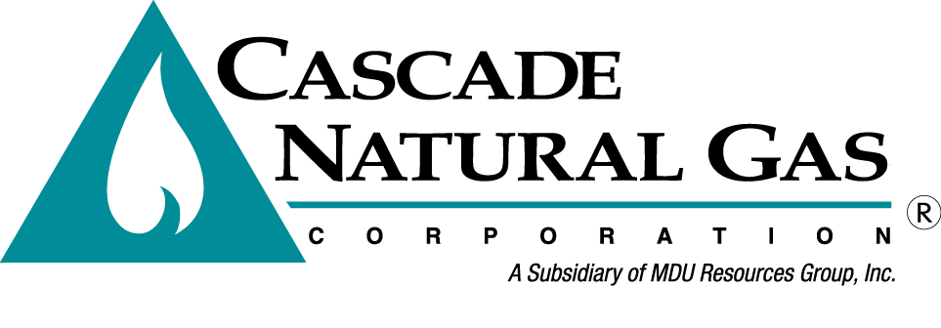
OPUC Tag Meeting 2

Date & Time: 9/5/2020, 09:00 AM – 10:45 AM
Location: OPUC Offices in Salem, OR – Meadow Room
In attendance: Mark Sellers-Vaughn, Brian Robertson, Devin McGreal, Ashton Davis, Anna Kim (OPUC), Dan Kirschner (NWGA), Connor Reiten (NWGA), Teresa Hagins (NWP)
Called in: Eric Wood, Kevin Connell, Carolyn Stone, Monica Cowlishaw, Bruce Folsom, Linda Offerdahl, Mike Paruszkiewicz (NWN)
Minutes by: Brian Robertson

Mark kicked off the meeting by thanking everyone that showed up. Brian asked Anna to explain fire safety of their building.
- Brian went through introductions and the agenda.
- Brian shared a map of Cascade’s service territory and explained how spread out the service territory was.
- Ashton discussed the demand forecast and key assumptions regarding the demand forecast.
  - Explained different statistics used to measure the accuracy of each model.
  - Explained how Cascade calculates HDDs.
  - Shared the seven different weather locations.
- Ashton then explained Cascade’s process for the use per customer and the customer forecasts with multiple flow charts.
- Ashton then described the customer forecast process further.
  - Anna asked if we were able to explain each Fourier term and Ashton responded saying yes.
- Ashton then described the use per customer forecast process further.
- Ashton talked about how Cascade, in the past, has used the coldest day in past 30-year history. Cascade mentioned looking at monte carlo scenarios for replacing the 30-year history methodology. Other stakeholders discussed using longer duration for cold weather modeling. Cascade has agreed to take a further look at long duration cold events.
- Brian discussed the forecast results as well as a non-weather dependent model and the result of those as well.
- Brian then went through some of the city’s experiencing low growth as well as city’s experiencing high growth.
- Brian shared the results of the forecast compared to past forecasts.
- Anna asked how new customer usage is modeled compared to older customers since newer customers usually have lower usages (more efficient houses). Brian explained the difficulties of determining the exact amount but it’s definitely something on Cascade’s radar.
- Brian gave an overview of the non-core outlook for Cascade. He explained how the non-core could impact the core through rate schedule changes.
- Devin discussed the market outlook and long-range price forecast.
- Devin explained how Cascade weights the different forecast sources and how we age dampen some of the forecasts.
- Brian asked if there were any questions regarding Cascade’s LC-69 2018 IRP Update filing. Anna said she did not have any questions.
- Brian also asked if there were questions regarding the stakeholder engagement document and there were no questions.
- Brian then explained that Cascade needs to lock down the forecast model so any issues with the forecast model need to be brought up as soon as possible. Anna asked Cascade to discuss with ETO to ensure they understand what they are receiving when we send out forecast model.
- Brian wrapped up the meeting discussing the remaining schedule.

TAG 3 will take place on November 6th, 2019 in Kennewick, WA at Cascade’s General Office Deschutes room.

The meeting was adjourned at 10:45 AM.

