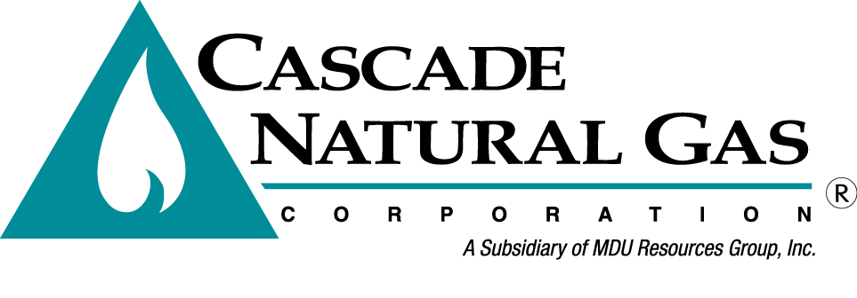
OPUC Tag Meeting 3

Date & Time: 11/6/2019, 09:00 AM – 12:00 PM
Location: Cascade Natural Gas General Office in Kennewick, WA – Deschutes Room
In attendance: Mark Sellers-Vaughn, Brian Robertson, Devin McGreal, Ashton Davis, Linda Offerdahl, Mike Parvinen, Eric Wood, Tom Pardee (Avista)
Called in: Bruce Folsom, Monica Cowlishaw, Garrett Senger, Jim Cordaro (Ruby), Mark Iverson (Ruby), Mike Paruszkiewicz (NWN), Anna Kim (OPUC)
Minutes by: Brian Robertson

Mark Sellers-Vaughn kicked off the meeting by thanking everyone that showed up. Brian went over fire safety of the building, introductions and the agenda.
- Jim and Mark from Kinder Morgan gave a presentation of the Ruby Pipeline as well as their view of the current energy market.
- Linda Offerdahl then presented Cascade’s Distribution System Planning.
  - Discussed System Overview.
  - Discussed the Synergy modeling and how it works.
  - Explained the data gathering process and how it’s implemented into Synergy.
  - Linda explained the pros and cons of several different solutions to pipeline pressure issues.
  - Anna asked how the new pipe size is determined if old pipe needs to be replaced. Linda responded and said it depends on future growth in the area.
  - Linda explained that the engineers put together the projects and shows other alternative projects. Management then decides which projects go in.
  - Linda then shared future projects that are currently planned in the state of Oregon.
- Eric Wood then described Cascade’s Gas Supply Overview.
  - Eric discussed the Company’s transportation, supply, and storage in depth.
  - Highlighted Cascade’s 2020 portfolio design.
  - Eric presented a peak day example for Cascade. Anna asked if that was the case for all peak events. Eric said no, there are many different ways to supply gas. Anna would like to see different examples added to the IRP.
- Brian Robertson then discussed Cascade’s SENDOUT modeling.
  - Brian shared the challenges of modeling as well as how SENDOUT has perfect knowledge.
  - Brian discussed the Resource Optimization Process. Brian noted that more information would be discussed at TAG 4.
  - Brian then explained how Cascade defines scenarios vs sensitivities.
- Ashton Davis presented alternative resources for Cascade.
  - These resources include incremental transportation, supply, and storage.
- Devin McGreal presented Cascade’s price forecast and avoided cost.
  - Devin shared the formula that Cascade is using for the 2020 avoided cost calculation.
  - Devin went in depth on several of the avoided cost inputs, such as carbon, distribution system planning, and risk premium.
  - Anna noted that Cascade’s carbon sensitivity was higher than other LDCs in UM-1893. Cascade will discuss this further at TAG 4.
- Brian wrapped up the meeting discussing the remaining schedule.

TAG 4 will take place on January 15th, 2020 at the Portland International Airport - Umatilla room.

The meeting was adjourned at 12:00 PM.

