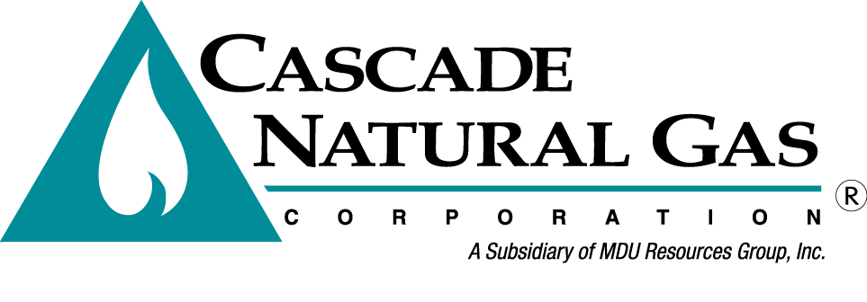
OPUC Tag Meeting 4

Date & Time: 1/15/2020, 09:00 AM – 12:30 PM
Location: Portland International Airport and Conference Center – Multnomah Room
In attendance: Brian Robertson, Ashton Davis, Devin McGreal, Alyn Spector, Bruce Folsom, Brian Cunnington, Linda Offerdahl, Anna Kim (OPUC), Jack Cullen (ETO), Bob Jenks (CUB), Sudeshna Pal (CUB)
Called in: Mike Parvinen, Abbie Krebsbach, Kevin Connell, Eric Wood, Chanda Marek, Chris Robbins, Monica Cowlishaw, Carolyn Stone, Tom Pardee (Avista), Mark Iverson (Kinder Morgan), Chad Stokes (Cable Huston)
Minutes by: Brian Robertson

Brian Robertson kicked off the meeting by thanking everyone that showed up. Brian went over fire safety of the building, introductions and the agenda.
- Brian Robertson discussed what Renewable Natural Gas (RNG) is for slides 4-7.
- Cascade mentioned that the Carbon Intensity factor is a topic that is being discussed intently in both OR and WA. The Company is involved in these discussions.
- Brian Robertson then discussed regulatory matters regarding RNG. Cascade is involved in the AR 632 and UM 2030 dockets in Oregon. The Company is also aware of SB 98 in OR and HB 1257 in WA as well as a few other documents.
Brian Robertson asked a question about expectations in the IRP regarding an IRP chapter. Anna Kim said Cascade should follow SB 98 rules and also noted that our IRP will be filed prior to SB 98 rules go in effect. Bob Jenks said since Cascade is a small utility that there isn’t a requirement to include RNG, but if Cascade plans to have RNG added as a resource then Cascade needs to introduce it in the IRP.
- Brian Cunnington then discussed market research, Cascade’s RNG goals, steps Cascade has taken so far, and a description of several options the Company has in its service territory.
- Jack Cullen presented Energy Trust of Oregon’s Energy Efficiency Resource Assessment (RA) and results.
- Jack discussed the purpose and background of the RA model. Bruce asked if the RA model and CPA, that’s done in Washington, are the same. Jack said essentially, yes.

A question was asked regarding the discount rate and Cascade noted that the Company is required to use the after-tax marginal weighted-average cost of capital. Another question was asked if the discount rate was too high. The resource planning team said in our opinion, no.
- Jack Cullen continued presenting the RA Model inputs and results. Jack discussed the different types of carbon scenarios Cascade and ETO were going to model. Jack also talked about the impacts of ramp rates and how ramp rate changes would have a bigger impact on savings than carbon scenarios would.
- Devin McGreal gave a short presentation on the carbon scenario impacts from Cascade’s perspective. Bob Jenks asked Cascade to also include a no carbon scenario.
- Devin continued and discussed SENDOUT® and Cascade’s resource optimization process.
- Ashton Davis discussed SENDOUT Supply and Storage inputs.
- Brian Robertson then talked about the transportation, constraints, demand, weather, and price in regard to SENDOUT inputs.
- Brian then shared Cascade’s preliminary results.
- Brian then discussed the remaining 2020 OR IRP schedule.

TAG 5 will take place on March 11th, 2020 at the OPUC offices in Salem, OR - Meadow room.

The meeting was adjourned at 12:30 PM.

