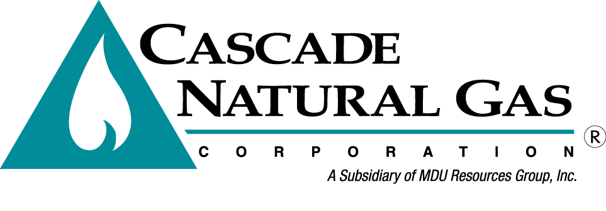
OPUC Tag Meeting 4

Date & Time: 3/11/2020, 09:00 AM – 10:30 PM
Location: OPUC offices in Salem, OR – Meadow Room
In attendance: Brian Robertson, Ashton Davis, Devin McGreal, Alyn Spector, Mike Parvinen, Mark Sellers-Vaughn, Nicholas Colombo (OPUC)
Called in: Kevin Connell, Eric Wood, Bruce Folsom, Carolyn Stone, Tom Pardee (Avista), Sudeshna Pal (CUB), Mike Paruszkiewicz (NWN)
Minutes by: Brian Robertson

Brian Robertson kicked off the meeting by thanking everyone that showed up. Brian went over fire safety of the building, introductions and the agenda.
- Brian Robertson quickly summarized alternative resources options Cascade has to add on the upstream side.
- Brian then reviewed Cascade’s Supply Resource Optimization Process that was presented at TAG 4. This was discussed in depth as it was Nicholas’ first exposure to Cascade’s process. Brian also recapped Cascade’s potential shortfalls from the as-is case.
- Ashton Davis then discussed Cascade’s list of candidate portfolios. Cascade’s candidate portfolios are as such:
  - All-In
  - All-In less DSM
  - GTN transportation Only
  - GTN Plus Storage
  - NWP transportation Only
  - NWP Plus Storage
  - Storage Only
Brian asked if there were any suggestion for other portfolios. Nicholas said it would be a good idea to add an RNG portfolio in future IRPs.
- Devin McGreal presented the methodology behind ranking of portfolios. Devin also discussed the risk-adjusted cost metric that Cascade utilizes to rank portfolios. Devin then shared the portfolios and their ranking.
- Devin discussed the top ranked candidate portfolio components and how it solves shortfalls.
- Brian then discussed the new stochastic methodology Cascade used for the weather and price Monte Carlo simulations. For weather, Cascade utilized the Cholesky Decomposition Matrix (CDM). For price, Cascade utilized the Geometric Brownian Motion as well as the CDM.
- Devin then presented the Company’s Scenario and Sensitivity Results. This included a discussion on High Growth and No Evergreen results. Both cases showed unserved demand, which was a red flag to Cascade. In both cases, Cascade found that these are scenario’s that the Company will want to monitor but it does not cause us to reject the candidate portfolio.
- Devin shared the unserved and cost results of all the scenarios and sensitivities discussed earlier.
- In Conclusion, the Company is satisfied with the results that all shortfalls will be served by DSM and 3rd party citygate deliveries. Cascade presented a slide showing Cascade does not anticipate any shortfalls under the preferred portfolio.
- Alan Spector discussed the four-year action plan for Environmental Policy as well as DSM.
- Brian Robertson discussed the four-year action plan for Demand, Resource Planning, and Distribution System Planning.
- Brian discussed the remaining 2020 OR IRP schedule and adjourned the meeting.
Cascade will file the draft IRP on May 12 and has a TAG 6 scheduled for June 30th, if needed.

The meeting was adjourned at 10:30 PM.

