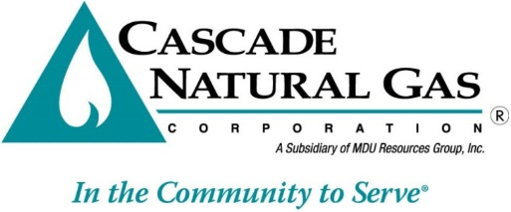

**CARES Advisory Group Meeting Agenda**

**May 21, 2025 2:00 – 3:00pm Pacific**

|  |  |
| --- | --- |
| **Advisory Group Member** |  |
| Blue Mountain Action Council (BMAC) | Sylvia Schaefer |
| Benton-Franklin Community Action Connections (CAC) | Dalia Ochoa |
| Community Action of Lewis, Mason, & Thurston Counties (CACLMT) | Ester Castro, Stephenie Arnold |
| Coastal Community Action Program (CCAP) | Debbie Gregg |
| Chelan-Douglas Community Action Council (CDCAC) | Tom Bonwell, Sarah Brito, Alan Walker |
| Kitsap Community Resources (KCR) | Kandi Balandran |
| Lower Columbia Community Action Center (LCCAP) | Kathy Bates |
| NW Community Action Center (NCAC) | Jose Alvarez |
| OIC of Washington (OIC) | Heidi Silva, Casandra Ochoa, Candi Jaeger |
| Opportunity Council (OPPCO) | Marie Stanley, Melissa Gong |
| Community Action of Skagit County (SCCAA) | Misty Velasquez |
| Snohomish County Human Services Dept (SCEAP) | Constance Hockett, Traci Baugh |
| WUTC Staff | Andrew Roberts, Andy Sellards, Corey Cook, Jacque Hawkins-Jones, Keith Quinata |
| The Energy Project | Shaylee Stokes |
| Public Counsel | Kai Hiatt |
| NW Energy Coalition | Charlee Thompson |
| Department of Commerce | Michelle DeBell |
| **Cascade Natural Gas** |  |
| Dan Tillis, Dir Customer Experience | Lori Blattner, Dir Regulatory Affairs |
| Teri Sovak, Mgr Customer Service, Credit & Collections | Noemi Ortiz, Mgr OR Conservation & Weatherization |
| Shannon Steed, Consumer Specialist | Jennifer Gross, Regulatory Analyst |
| Rodney Fowler, Business Analyst |  |

1. Follow-up items from the April meeting:
   1. CARES administrative agreement amendment for PEV has been distributed to agencies, and all have been signed and returned to Cascade except for one which is still in progress.
   2. LIHEAP calculation method (Shay)
2. Language access plan development (Empower Dataworks)
3. Q1 CBO report presentations by agencies
4. Open Discussion